

**Vehicle Management System Using Salesforce**

1. **INTRODUCTION** 
   1. Overview

Vehicle Management is an application where a customer Details are stored inorder to choose cars, bikes and commercial vehicles for travel with in the city. The data which is stored here is further used to remind them if any offers are provided during the seasons and any updates regarding vehicles are sent to them in the form of messages and mails

* 1. Purpose

Create and manage vehicle records to optimize the usage of your trucks and trailers that carry inventories to stores. To track the vehicles that carry goods out of a warehouse, assign them to that warehouse.

1. **Problem Definition & Design Thinking** 
   1. Empathy Map

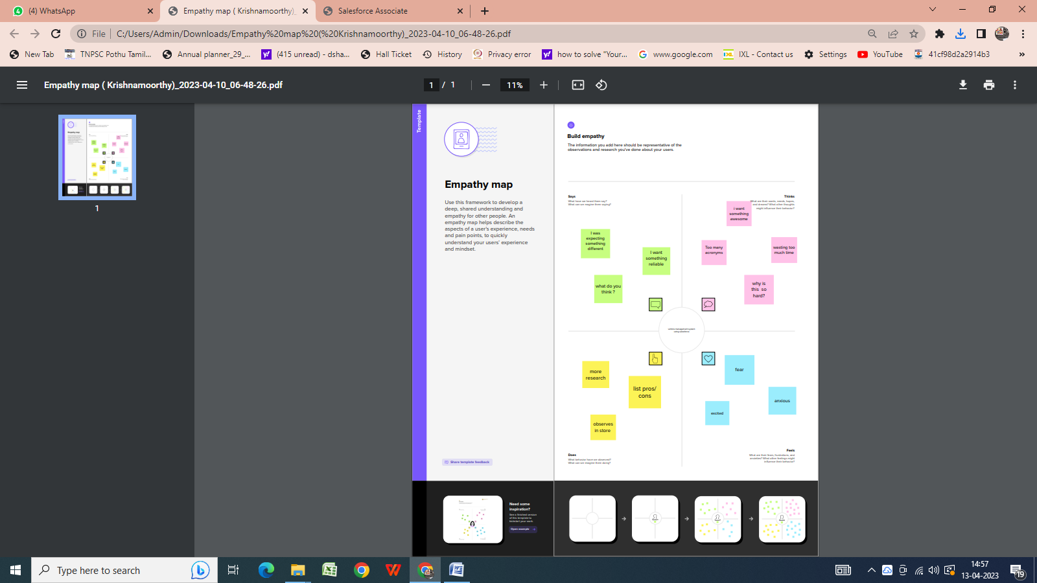

* 1. Ideation & Brainstorming Map

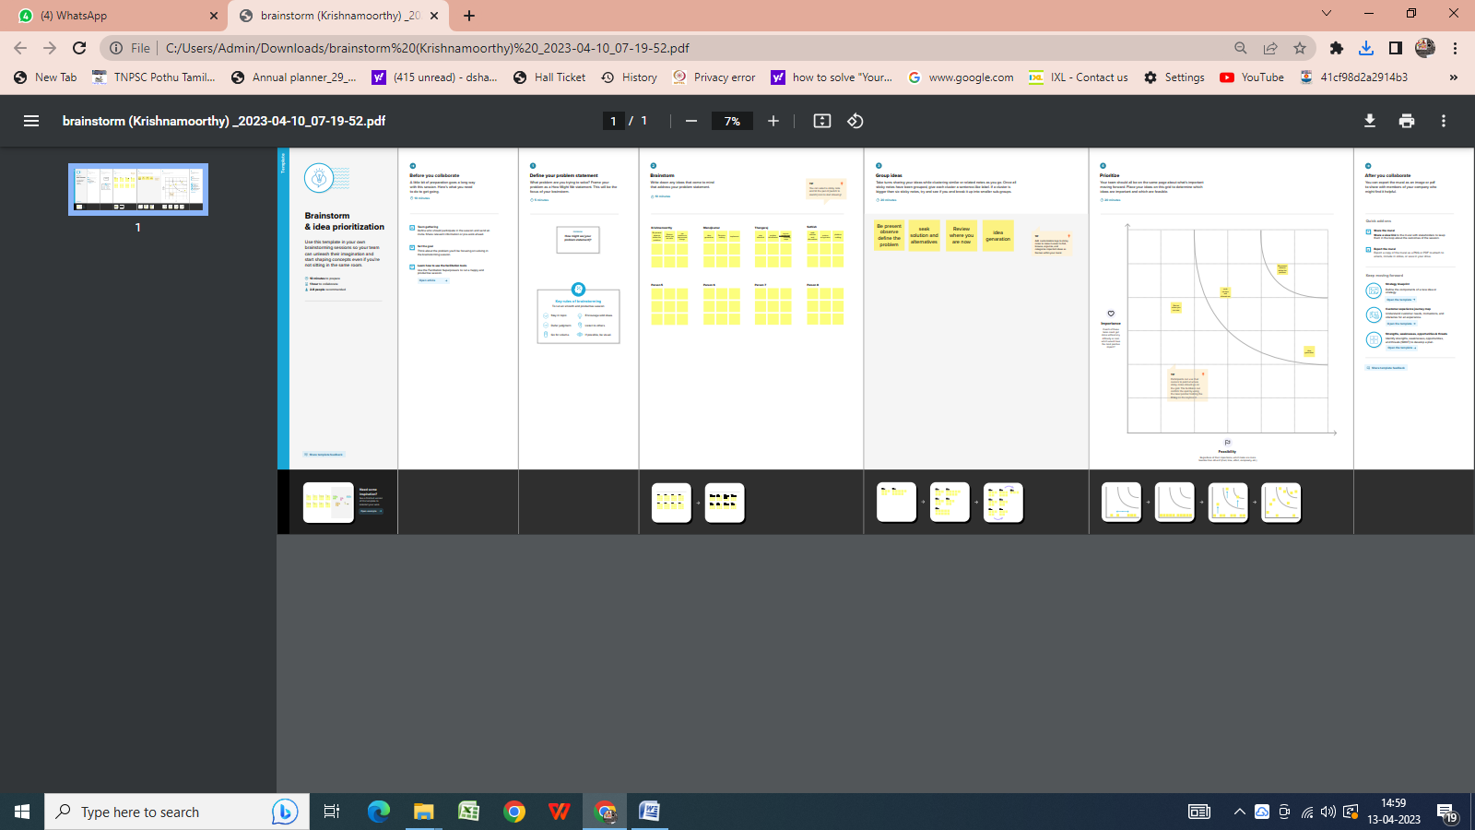

1. **RESULT** 
   1. Data Model:

|  |  |  |
| --- | --- | --- |
| **Object name** | **Fields in the Object** | |
| obj1 | Field label | Data type |
|  |  |  |
| Vehicle | Vehicle | Auto Number |
|  |  |  |
| Obj2 | Field label | Data type |
|  |  |  |
|  |  |  |
|  |  |  |

* 1. Activity & Screenshot

Attach the screenshots of your project activity along with the

description.

1. **Trailhead Profile Public URL**

**Team Lead - https://trailblazer.me/id/mkumar2831**

**Team Member 1 - https://trailblazer.me/id/kmagic2**

**Team Member 2 - https://trailblazer.me/id/ssathish56**

**Team Member 3 –** **https://trailblazer.me/id/rbharathi19**

1. **ADVANTAGES & DISADVANTAGE**

Create and manage vehicle records to optimize the usage of your trucks and trailers that carry inventories to stores. To track the vehicles that carry goods out of a warehouse, assign them to that warehouse.

1. **APPLICATIONS**

Salesforce Cab Management System helps to undertake automate streamlining of cabs for the routes generated by admin. The system includes driver management, drop point management, vehicle management and booking system. This application can be used for administering the internal office cabs.

1. **CONCLUSION**

This application provides an easy and simple way to sell or purchase vehicles online. Customers can vie wall the details of the vehicles and can purchase the vehicle. Customers can view all the details of the vehicle and send a request if he wants to purchase the vehicle.

1. **FUTURE SCOPE**

* Compatible with Salesforce Lightning.
* User has the option to link the driver with the specific vehicle.
* A separate tab for listing of drivers and assigning routes to them. It allows to manage the assigned cabs dispatched for particular route.